Toilet Paper Roll Dispenser (TPRD)

Jacob McCall && Andrew Shelton

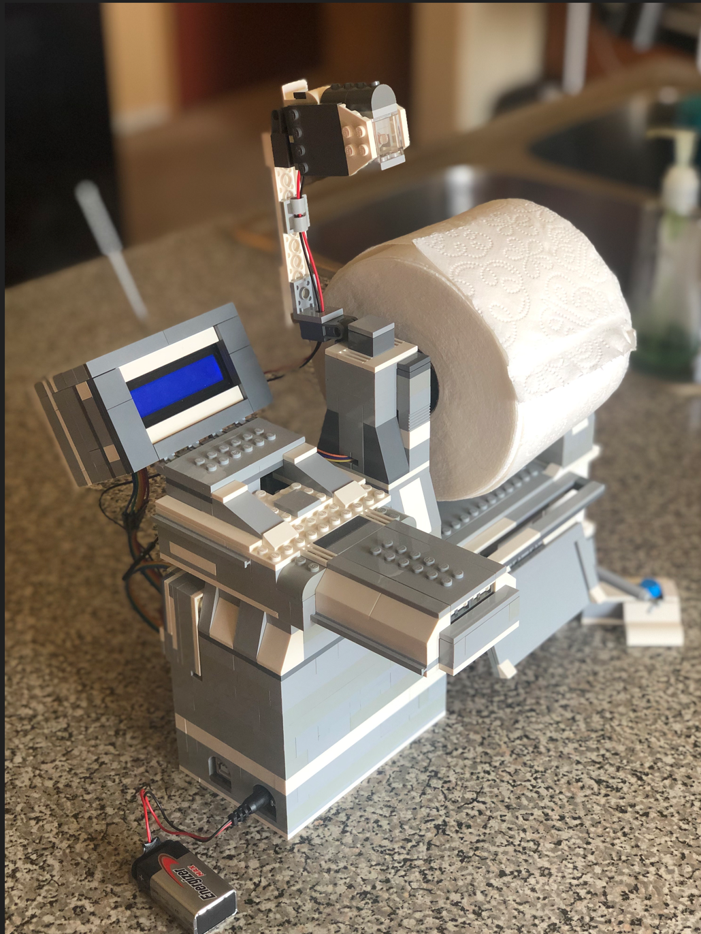

Project Description:

The **TPRD** is a light sensor–based device that spins a roll of toilet paper to dispense it for the user to grab and use. Various components work together to make this possible: a movable light sensor that activates when a hand is waved, a screen display to notify the user with relevant information, an internal clock to log when the machine is used, and extra buttons to start, reset, and adjust the amount of toilet paper being dispensed.

Components:

**Body**

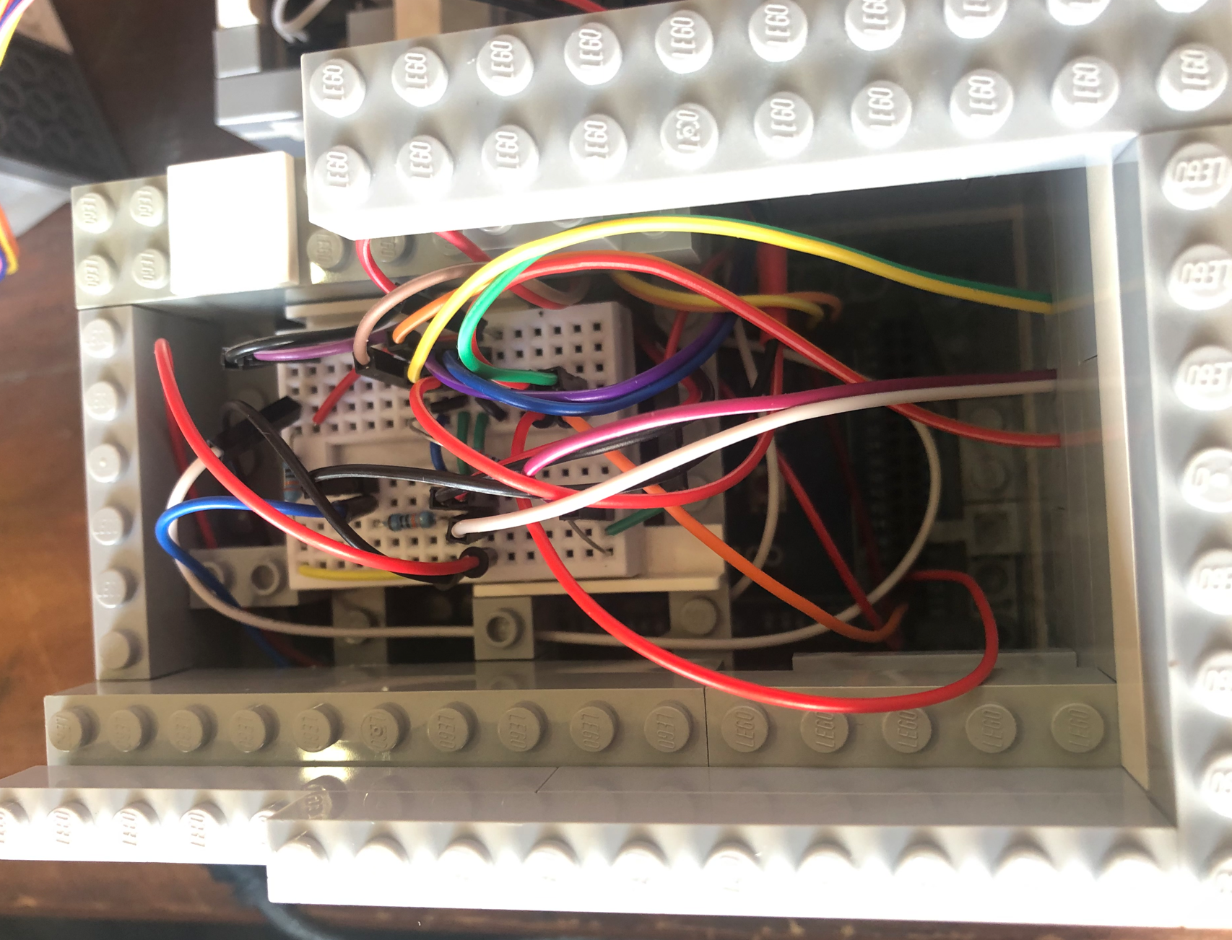

The body component houses the Arduino microprocessor, which allows you to connect to a computer and view serial monitor output. The circuit includes a small breadboard with the necessary pull-up resistors for each component.

**Internal Real Time Clock (RTC)**

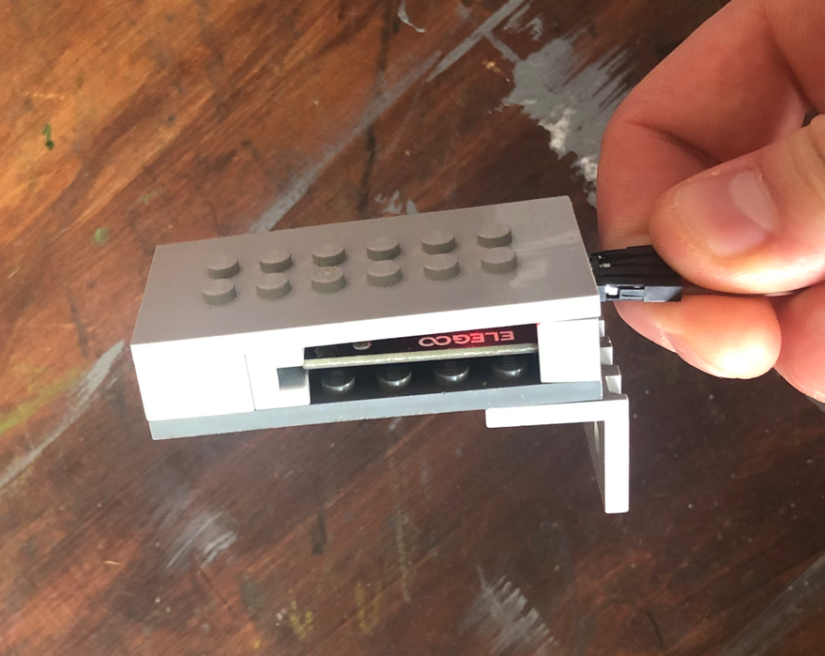

The RTC component contains a small battery that allows it to keep track of time even when the circuit is powered off. When the processor requests the current time, the RTC responds with the most up to date time it has stored.

**Liquid Crystal Display (LCD)**

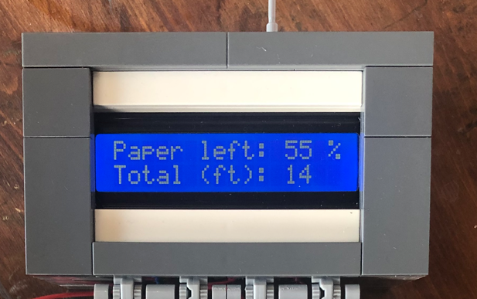

The LCD component has 32 cells that display two pieces of information, which update after each dispense: first, how much toilet paper is left on the roll; and second, the total amount of feet you've ever used (to make you feel bad).

**External Battery Source / Motor Driver Board (MDB)**

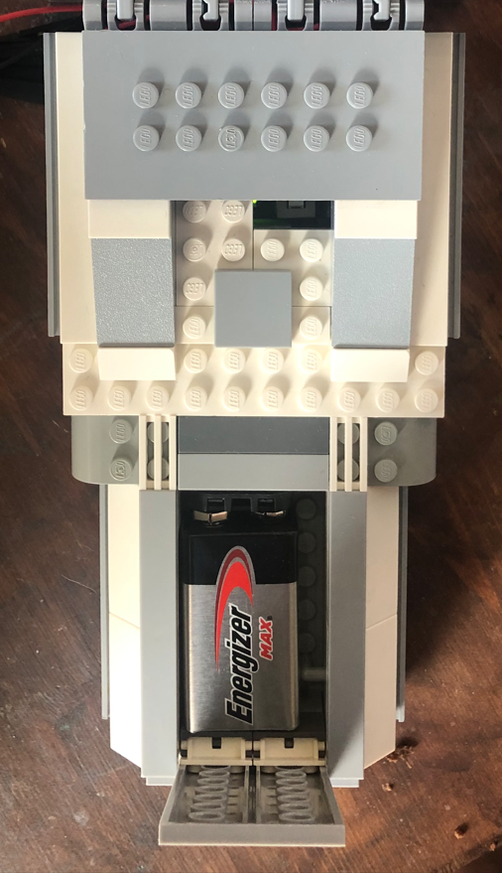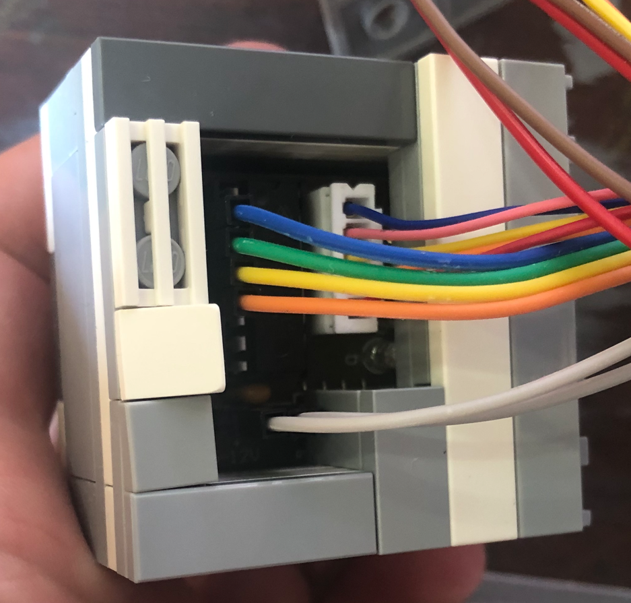

These two components are used to supply additional power to the motor, separate from the main microcontroller power. A 9V battery can be connected and turned on, which then feeds into the MDB. The MDB receives control signals from the microcontroller, allowing it to activate the motor without overloading the microcontroller's power supply.

**Photoresistor**

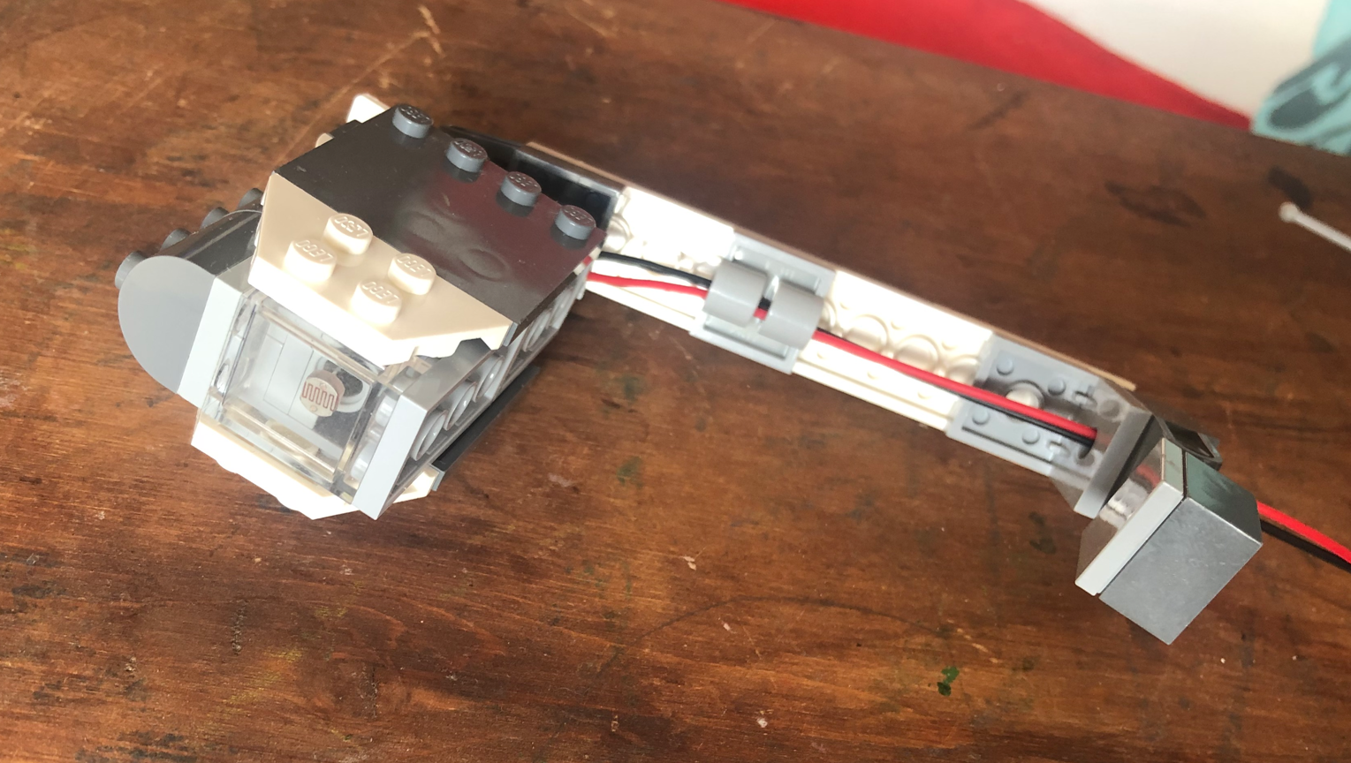

The photoresistor is a light sensitive analog component that decreases its resistance as light intensity increases. In this project, it detects a hand wave by sensing a change in light, which reduces resistance and alters the voltage. This change is used to trigger events in the microcontroller.

**Motor Stepper**

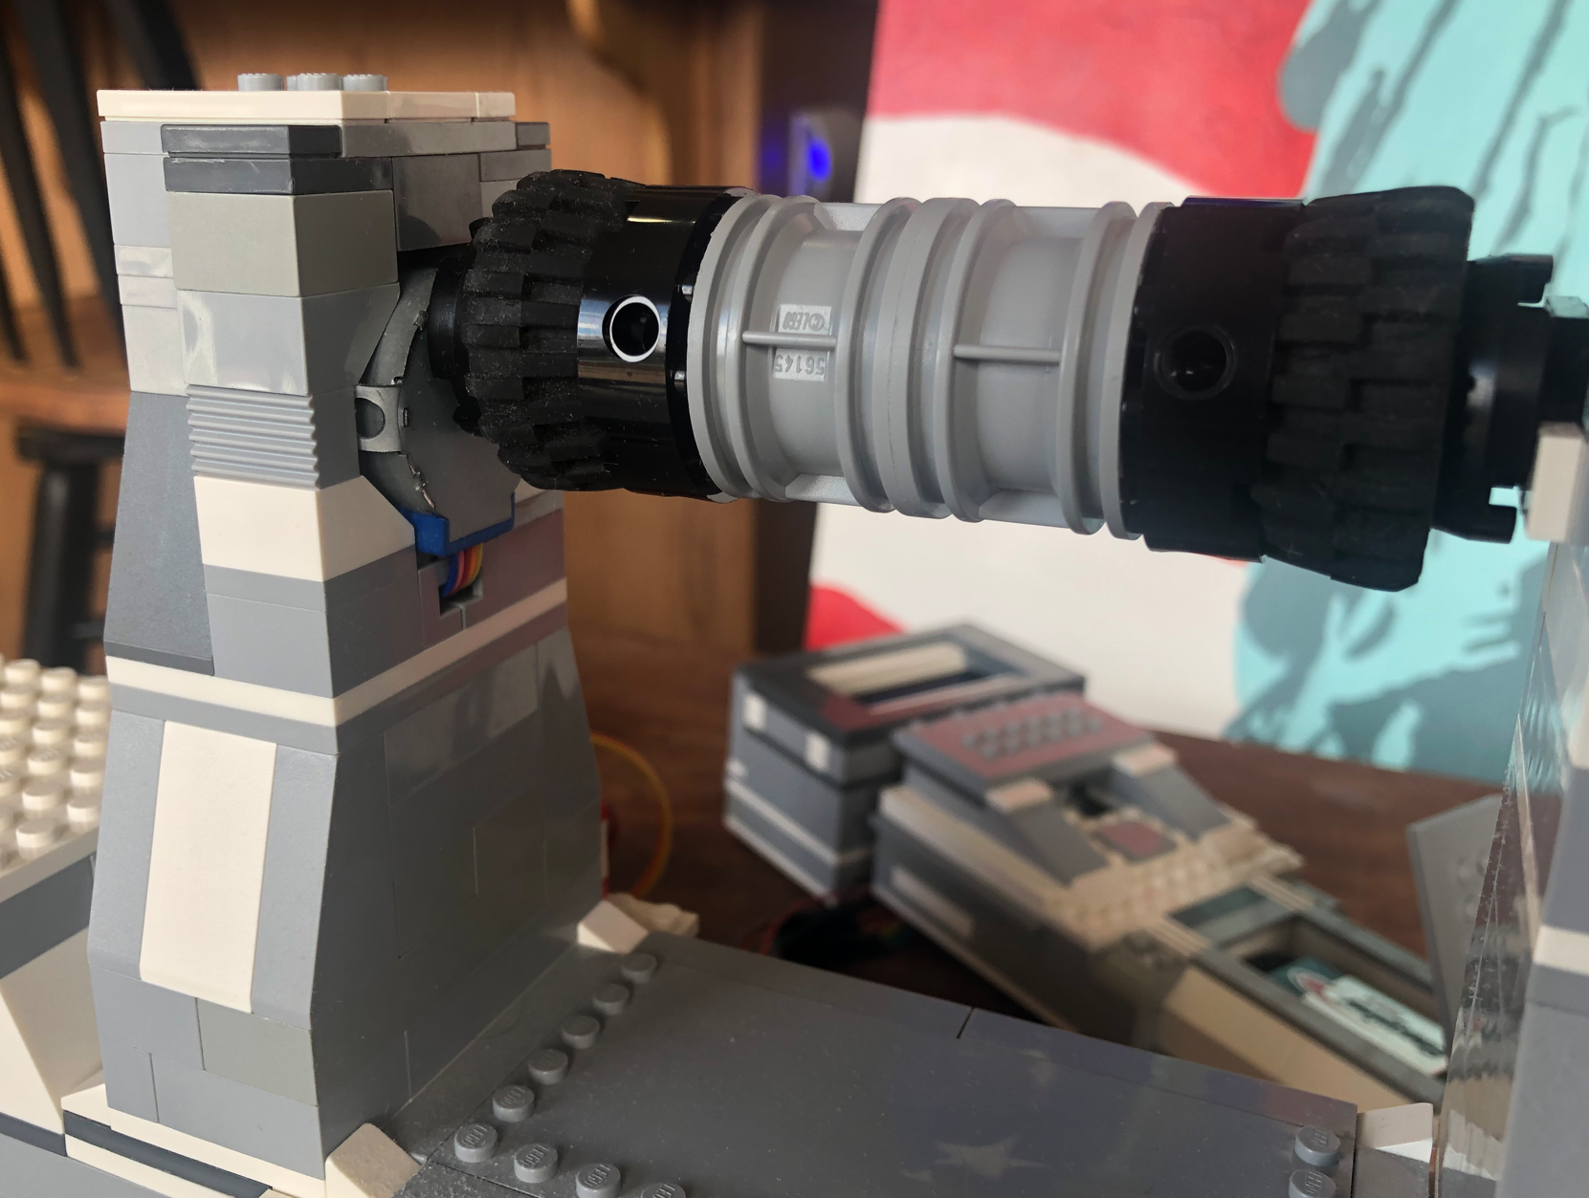

The motor component rotates the toilet paper roll downward. It activates when the light sensor is triggered and rotates long enough to dispense one to four squares of paper, depending on the dial adjustment

**Red/Green Light Indicator**

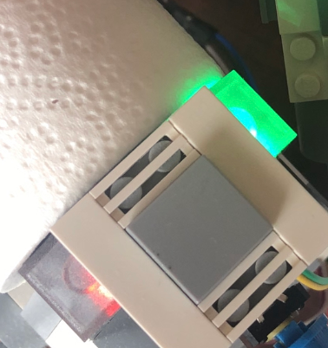

The red and green LED components provide a visual indicator of the system's state. The green LED means the dispenser is active and all components are operational. The red LED is triggered when the toilet paper roll is below 5%, signaling a low supply. This condition disables the photoresistor and motor until the system is reset and the green LED is active again.

**Reset Button**

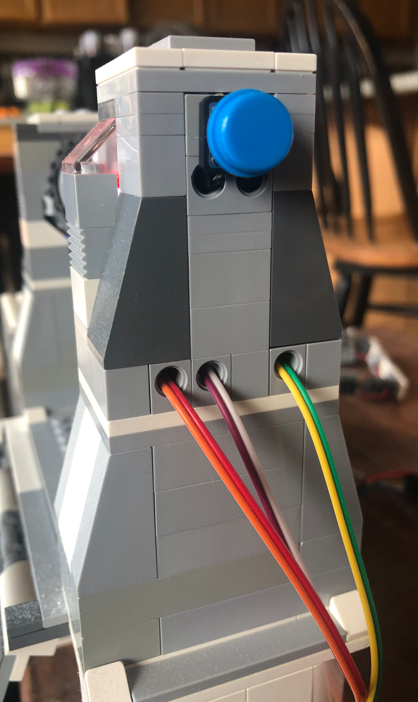

The reset button can be pressed at any time, whether the system is on or off. It uses an interrupt to signal the microcontroller to reset the toilet paper roll status back to full. If the red LED was on, the system will return to the green LED state, enabling normal operations again.

**Start Button**

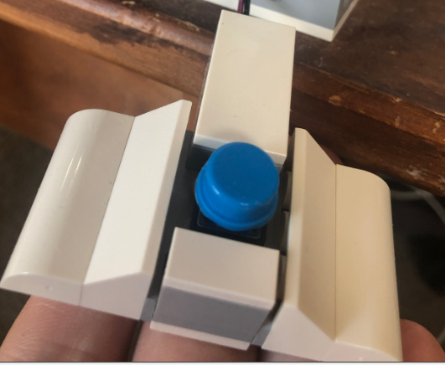

This button is another interrupt based input that toggles the device between ON and OFF states. When turned ON, it initiates a light calibration to adjust to the current room lighting, then enables all other components. Turning it OFF disables all component functions to save on power consumption.

**Potentiometer**

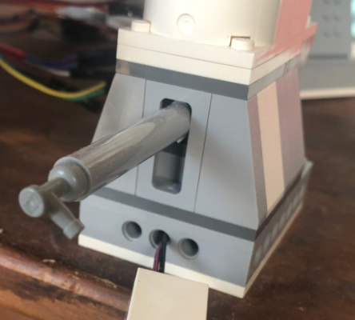

This component is an analog input used to adjust how much toilet paper is dispensed per activation. When turned fully left, it dispenses one square; fully right, it dispenses four. In between positions scale. The dial increases resistance as it's turned, changing the voltage level read by the microcontroller's analog pin.

System Overview:

The toilet paper roll dispenser is designed to dispense toilet paper using a light activated sensor. The entire system is controlled by an Arduino Mega 2560 and includes the following components:

* A photoresistor to detect hand motion in changes with light.
  + Will run when start is on.
  + Each startting phase it will gather 5 light reading in one second intervals and take the average and a multiplyer to figure out what light drop level is needed to flag.
  + Will run each loop to see if new light level is below threshold, if so it will activate the motor.
* A stepper motor to rotate and dispense the toilet paper roll.
  + Is triggered when the light level is low.
  + Will rotate depending on the photoresistor level, it will always dispense the length of one paper square. Can go up to four squares.
  + Will inscrease total toilet paper usage number and decrease how much remaining toilet paper is avalible.
  + Will flag to the serial monitor the time it was used.
* A potentiometer to adjust how much paper is dispensed per activation.
  + Will run when start is on.
  + Dial all the way to the left will have value at 1 and all the way to the right is at max.
  + Update its value each loop.
* An LCD to display system information, such as usage and remaining supply.
  + Will display toilet paper usage of all time.
  + Will display how much percept toilet paper is left.
  + Will only turn on and updated at the end of each loop as long as the system is on.
* An RTC (real-time clock) to log timestamps after each use.
  + Will run off a external batery even when this system is off.
  + When the system turn off it will save the currnt time.
  + When system turns on it will display in serial monitor when the last use was.
  + Will save a new value after each motor use.
* EEPROM memory to store system data like usage history and supply level.
  + Will save all elements of system time (YYYY/MM/DD/HH/MM/SS).
  + Will save total all time use of toilet paper.
  + Will save how much toilet paper has been used up in current roll.
* An interrupt button to toggle the system power on or off.
  + Will be on at all times while the Audrino has a power supply.
  + On activation it will flag all values to turn on and mention last time used.
  + Pressed again will deactivate it and will save the current time and turn off device.
* A second interrupt button to reset the toilet paper supply status.
  + When pressed it will reset the value of how much toilet paper is left back to 100%.
  + Will reset the red error light back to green.
  + Can be used at any time as long as the Audrino has power.
* A 9V power supply connected through a motor driver to prevent overloading the microcontroller.
  + Will activate by Audrino to use its power suplly for the motor.
  + Will require to turn off seperatly by pressing button.
* A red and green LED light to indicate working and none working conditions.
  + Green LED will turn on when the device is running and does not need a reset because it is out of toilet paper.
  + Red LED will turn on when the threshold of toilet paper percent left is under 5%.
  + Will freeze the other funtions until the reset is pressed.

Schematic Diagram: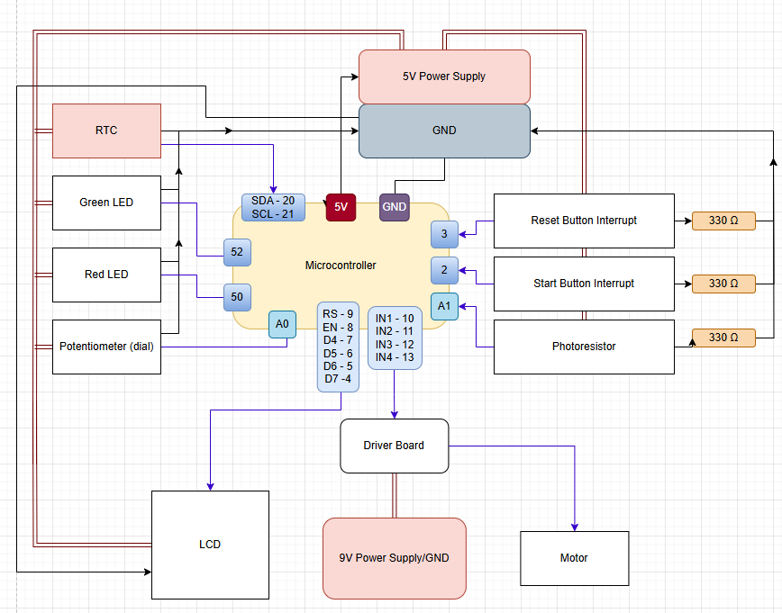

**Microcontroller with Arduino Mega 2560** ↓

[ATmega640/1280/1281/2560/2561 datasheet](https://ww1.microchip.com/downloads/en/DeviceDoc/Atmel-2549-8-bit-AVR-Microcontroller-ATmega640-1280-1281-2560-2561_datasheet.pdf)

https://ww1.microchip.com/downloads/en/DeviceDoc/Atmel-2549-8-bit-AVR-Microcontroller-ATmega640-1280-1281-2560-2561_datasheet.pdf

**RTC** ↓

[RTC integration with Arduino MEGA - Projects / General Guidance - Arduino Forum](https://forum.arduino.cc/t/rtc-integration-with-arduino-mega/925999)

https://forum.arduino.cc/t/rtc-integration-with-arduino-mega/925999

**Interrupt** ↓

[attachInterrupt() | Arduino Documentation](https://docs.arduino.cc/language-reference/en/functions/external-interrupts/attachInterrupt/)

<https://docs.arduino.cc/language-reference/en/functions/external-interrupts/attachInterrupt/>

**Photoresistor** ↓

[Very simple alarm using a photoresistor | Arduino Project Hub](https://projecthub.arduino.cc/galoebn/very-simple-alarm-using-a-photoresistor-d13931)

<https://projecthub.arduino.cc/galoebn/very-simple-alarm-using-a-photoresistor-d13931>

Potentiometer

[Lesson 8 Controlling an LED by Potentiometer — SunFounder uno-and-mega-kit documentation](https://docs.sunfounder.com/projects/uno-mega-kit/en/latest/mega2560/controlling_an_led_by_potentiometer.html)

https://docs.sunfounder.com/projects/uno-mega-kit/en/latest/mega2560/controlling_an_led_by_potentiometer.html

**LCD** ↓

[How to Use 16x2 I2C LCD: Pinouts, Specs, and Examples | Cirkit Designer](https://docs.cirkitdesigner.com/component/b267f8d2-c87b-b7af-ebd1-2026a4fdc261/16x2-i2c-lcd)

<https://docs.cirkitdesigner.com/component/b267f8d2-c87b-b7af-ebd1-2026a4fdc261/16x2-i2c-lcd>

**LED** ↓

[How to Blink a LED with Arduino Mega](https://www.geekering.com/categories/embedded-sytems/arduino/joao-louro/arduino-mega-blinking-a-led/)

<https://www.geekering.com/categories/embedded-sytems/arduino/joao-louro/arduino-mega-blinking-a-led/>

**Driver Board (Rev3)** ↓

[Mega 2560 Rev3 | Arduino Documentation](https://docs.arduino.cc/hardware/mega-2560/)

https://docs.arduino.cc/hardware/mega-2560/